**Spring MVC Assignment**

//HelloController.java

package mvc1.controller;

import org.springframework.stereotype.Controller;

import org.springframework.web.bind.annotation.RequestMapping;

@Controller

public class HelloController {

@RequestMapping("/")

public String display()

{

return "index";

}

}

//helloworld.jsp

<%@ page contentType=*"text/html;charset=UTF-8"* language=*"java"* %>

<html>

<head>

</head>

<body>

<h1>This is a home page

called by home controller</h1>

</body>

</html>

//assignment1-servlet

<?xml version="1.0" encoding="UTF-8"?>

<beans xmlns="http://www.springframework.org/schema/beans"

xmlns:xsi="http://www.w3.org/2001/XMLSchema-instance"

xmlns:context="http://www.springframework.org/schema/context"

xmlns:mvc="http://www.springframework.org/schema/mvc"

xsi:schemaLocation="

http://www.springframework.org/schema/beans

http://www.springframework.org/schema/beans/spring-beans.xsd

http://www.springframework.org/schema/context

http://www.springframework.org/schema/context/spring-context.xsd

http://www.springframework.org/schema/mvc

http://www.springframework.org/schema/mvc/spring-mvc.xsd">

<!-- Provide support for component scanning -->

<context:component-scan base-package="com.javatpoint" />

<!--Provide support for conversion, formatting and validation -->

<mvc:annotation-driven/>

</beans>

//index.jsp

<html>

<body>

<p>Welcome to Spring MVC Tutorial</p>

</body>

</html>

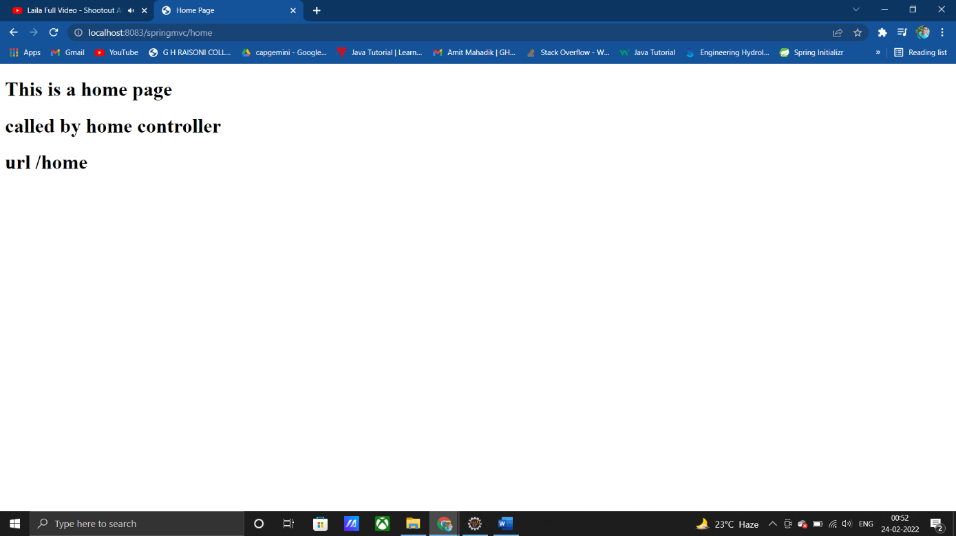

2)

//Controller.java

package com.mvc2;

import org.springframework.stereotype.Controller;

import org.springframework.ui.Model;

import org.springframework.web.bind.annotation.RequestMapping;

import org.springframework.web.bind.annotation.RequestMethod;

import org.springframework.web.bind.annotation.RequestParam;

//method = RequestMethod.POST

@Controller

public class controller {

@RequestMapping(path = "/simpleinterest",method = RequestMethod.POST)

public String simpleInterest(@RequestParam("principal")int principal,

@RequestParam("rate") int rate,

@RequestParam("time")int time,

Model model){

System.out.println("This is my simple interest page");

int si = (principal*time*rate)/100;

model.addAttribute("simpleinterest",si);

return "simpleinterest";

}

}

//assignment2-servlet

<?xml version="1.0" encoding="UTF-8"?>

<beans xmlns:xsi="http://www.w3.org/2001/XMLSchema-instance"

xmlns:context="http://www.springframework.org/schema/context"

xmlns="http://www.springframework.org/schema/beans"

xsi:schemaLocation="http://www.springframework.org/schema/beans

http://www.springframework.org/schema/beans/spring-beans.xsd

http://www.springframework.org/schema/context

http://www.springframework.org/schema/context/spring-context.xsd">

<context:component-scan base-package="org.example.controller"/>

<context:annotation-config/>

<!-- configure-view resolver -->

<bean class="org.springframework.web.servlet.view.InternalResourceViewResolver" name="viewResolver">

<property name="prefix" value = "/WEB-INF/views/"/>

<property name="suffix" value = ".jsp"/>

</bean>

</beans>

//Simpleinterest.jsp

<%@ page language=*"java"* contentType=*"text/html; charset=ISO-8859-1"*

pageEncoding=*"ISO-8859-1"*%>

<%@ page isELIgnored=*"false"* %>

<!DOCTYPE html>

<html>

<head>

<meta charset=*"ISO-8859-1"*>

<title>Simple Interest</title>

</head>

<style>

* {

margin: *0*;

padding: *0*;

box-sizing: *border-box*;

font-family: *"Poppins", sans-serif*;

}

**body** {

display: *flex*;

height: *100vh*;

justify-content: *center*;

align-items: *center*;

background: *linear-gradient(135deg, #ec3a3a, #f0740e)*;

}

*.container* {

max-width: *700px*;

width: *100%*;

background: *#fff*;

padding: *25px 30px*;

border-radius: *5px*;

}

</style>

<body>

<div class=*"container"*>

<h1>Simple interest is: ${simpleinterest}</h1>

</div>

</body>

</html>

//index.jsp

<!DOCTYPE html>

<html lang=*"en"*>

<head>

<meta charset=*"UTF-8"*>

<meta http-equiv=*"X-UA-Compatible"* content=*"IE=edge"*>

<meta name=*"viewport"* content=*"width=device-width, initial-scale=1.0"*>

<title>Simple Interest Calculator</title>

</head>

<style>

@import *url("https://fonts.googleapis.com/css2?family=Poppins&display=swap")*;

* {

margin: *0*;

padding: *0*;

box-sizing: *border-box*;

font-family: *"Poppins", sans-serif*;

}

**body** {

display: *flex*;

height: *100vh*;

justify-content: *center*;

align-items: *center*;

background: (*135deg, #ec3a3a, #f0740e)*;

}

*.container* {

max-width: *700px*;

width: *100%*;

background: *#fff*;

padding: *25px 30px*;

border-radius: *5px*;

}

*.container* *.title* {

font-size: *25px*;

font-weight: *500*;

}

*.container* *.title-end*{

display: *flex*;

text-align: *center*;

justify-content: *center*;

}

*.title-end* *.name*{

padding-left: *5px*;

font-size: *20px*;

font-weight: *800*;

}

**p**{

color: *#ec3a3a*;

}

*.container.title::before* {

content: *""*;

position: *absolute*;

left: *0*;

bottom: *0*;

height: *3px*;

width: *30px*;

background: *linear-gradient(135deg, #ec3a3a, #f0740e)*;

}

*.container* **form** *.user-details* {

display: *flex*;

flex-wrap: *wrap*;

justify-content: *space-between*;

margin: *20px 0 12px 0*;

}

**form** *.user-details* *.input-box* {

margin-bottom: *15px*;

width: *calc(100% / 2)*;

}

*.user-details* *.input-box* **input** {

height: *45px*;

width: *300px*;

outline: *none*;

border-radius: *5px*;

border: *1px solid #ccc*;

padding-left: *15px*;

transition: *all 0.3s ease*;

}

**form** *.button*{

height: *45px*;

margin: *45px 0*;

}

**form** *.button* **input**{

height: *100%*;

width: *100%*;

outline: *none*;

color: *#fff*;

border: *none*;

font-size: *18px*;

font-weight: *500*;

letter-spacing: *1px*;

border-radius: *5px*;

background: *linear-gradient(135deg, #ec3a3a, #f0740e)*;

}

**form** *.button* **input***:hover*{

background: *linear-gradient(-135deg, #ec3a3a, #f0740e)*;

}

@media(max-width: 584px){

*.container*{

max-width: *100%*;

}

**form** *.user-details* *.input-box*{

margin-bottom: *15px*;

width: *100%*;

}

*.container* **form** *.user-details*{

max-height: *300px*;

overflow-y: *scroll*;

}

*.user-details::-webkit-scrollbar*{

width: *0*;

}

}

</style>

<body>

<div class=*"container"*>

<div class=*"title"*>

Simple Interest Calculator

</div>

<form method = *"post"* action=*"simpleinterest"* class=*"form"* name=*"SI"* id=*"form"*>

<div class=*"user-details"*>

<div class=*"input-box"*>

<span class=*"details"*>Principal Amount</span>

<input type=*"text"* placeholder=*"Enter the principal amount"* name=*"principal"* required>

</div>

<div class=*"input-box"*>

<span class=*"details"*>Rate of Interest</span>

<input type=*"text"* placeholder=*"Enter the rate of interest"* name=*"rate"* required>

</div>

<div class=*"input-box"*>

<span class=*"details"*>Time Period</span>

<input type=*"text"* placeholder=*"Enter the time period"* name=*"time"* required>

</div>

</div>

<div class=*"button"*>

<input type=*"submit"* value=*"Calculate Simple Interest"*>

</div>

</form>

<div class=*"title-end"*>

Made by <div class=*"name"*>

<p>Himanshu Wakade</p>

</div>

</div>

</div>

</body>

</html>

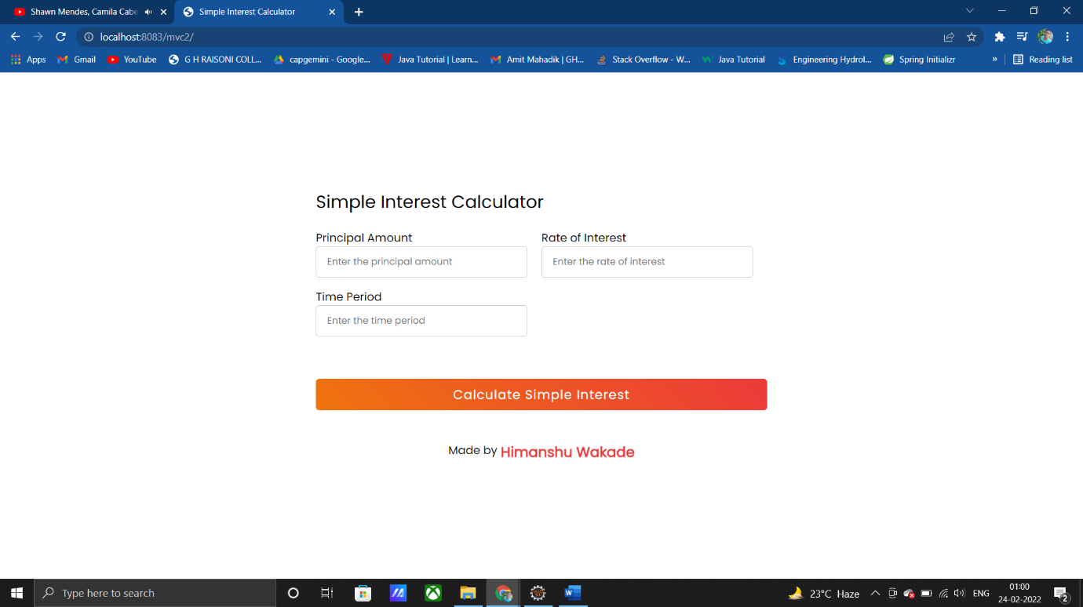

3)

//controller.java

package mvc3.controller;

import org.springframework.stereotype.Controller;

import org.springframework.web.bind.annotation.RequestMapping;

import org.springframework.web.bind.annotation.RequestMethod;

import org.springframework.web.bind.annotation.RequestParam;

import org.springframework.web.servlet.ModelAndView;

@Controller

public class controller {

@RequestMapping(path = "/login",method = RequestMethod.POST)

public ModelAndView login(@RequestParam("username")String username, @RequestParam("password")String password){

UserModel userModel = new UserModel();

userModel.setEmail("abc@gmail.com");

userModel.setUsername("abc");

userModel.setPassword("1234");

if(username.equals(userModel.getUsername()) && password.equals(userModel.getPassword())){

ModelAndView modelAndView = new ModelAndView("success");

modelAndView.addObject("user",userModel);

return modelAndView;

}

else {

return new ModelAndView("error");

}

}

}

//UserModel.java

**package** mvc3.controller;

**public** **class** UserModel {

**private** String username;

**private** String email;

**private** String password;

**public** UserModel() {

}

**public** UserModel(String username, String email, String password) {

**this**.username = username;

**this**.email = email;

**this**.password = password;

}

**public** String getUsername() {

**return** username;

}

**public** **void** setUsername(String username) {

**this**.username = username;

}

**public** String getEmail() {

**return** email;

}

**public** **void** setEmail(String email) {

**this**.email = email;

}

**public** String getPassword() {

**return** password;

}

**public** **void** setPassword(String password) {

**this**.password = password;

}

@Override

**public** String toString() {

**return** "UserModel:[" +

"username='" + username + '\n' +

", email='" + email + '\n' +

", password='" + password + '\n' +

']';

}

}

//error.jsp

<%--

Created by IntelliJ IDEA.

User: 07ayu

Date: 09-02-2022

Time: 22:44

To change this template use File | Settings | File Templates.

--%>

<%@ page contentType=*"text/html;charset=UTF-8"* language=*"java"* %>

<html>

<head>

<title>Error Page</title>

</head>

<body>

<h1 align=*"center"* color=*"red"*>Username or password is incorrect</h1>

</body>

</html>

//success.jsp

<%--

Created by IntelliJ IDEA.

User: 07ayu

Date: 09-02-2022

Time: 22:44

To change this template use File | Settings | File Templates.

--%>

<%@ page contentType=*"text/html;charset=UTF-8"* language=*"java"* %>

<%@ page isELIgnored=*"false"* %>

<html>

<head>

<title>Success Page</title>

</head>

<body>

<h1 color=*"green"*>Welcome ${user.username}</h1>

<hr>

<h1 color=*"green"*>Email Id is: ${user.email}</h1>

<hr>

<h1 color=*"green"*>Password is: ${user.password}</h1>

</body>

</html>

//assignment3-servlet

<?xml version="1.0" encoding="UTF-8"?>

<beans xmlns:xsi="http://www.w3.org/2001/XMLSchema-instance"

xmlns:context="http://www.springframework.org/schema/context"

xmlns="http://www.springframework.org/schema/beans"

xsi:schemaLocation="http://www.springframework.org/schema/beans

http://www.springframework.org/schema/beans/spring-beans.xsd

http://www.springframework.org/schema/context

http://www.springframework.org/schema/context/spring-context.xsd">

<context:component-scan base-package="org.example.controller"/>

<context:annotation-config/>

<!-- configure-view resolver -->

<bean class="org.springframework.web.servlet.view.InternalResourceViewResolver" name="viewResolver">

<property name="prefix" value = "/WEB-INF/views/"/>

<property name="suffix" value = ".jsp"/>

</bean>

</beans>

//index.jsp

<!DOCTYPE html>

<html lang=*"en"*>

<head>

<meta charset=*"UTF-8"*>

<meta http-equiv=*"X-UA-Compatible"* content=*"IE=edge"*>

<meta name=*"viewport"* content=*"width=device-width, initial-scale=1.0"*>

<title>Simple Interest Calculator</title>

</head>

<style>

@import *url("https://fonts.googleapis.com/css2?family=Poppins&display=swap")*;

* {

margin: *0*;

padding: *0*;

box-sizing: *border-box*;

font-family: *"Poppins", sans-serif*;

}

**body** {

display: *flex*;

height: *100vh*;

justify-content: *center*;

align-items: *center*;

background: *linear-gradient(135deg, #ec3a3a, #f0740e)*;

}

*.container* {

max-width: *700px*;

width: *100%*;

background: *#fff*;

padding: *25px 30px*;

border-radius: *5px*;

}

*.container* *.title* {

font-size: *25px*;

font-weight: *500*;

}

*.container* *.title-end*{

display: *flex*;

text-align: *center*;

justify-content: *center*;

}

*.title-end* *.name*{

padding-left: *5px*;

font-size: *18px*;

font-weight: *800*;

}

**p**{

color: *#ec3a3a*;

}

*.container.title::before* {

content: *""*;

position: *absolute*;

left: *0*;

bottom: *0*;

height: *3px*;

width: *30px*;

background: *linear-gradient(135deg, #ec3a3a, #f0740e)*;

}

*.container* **form** *.user-details* {

display: *flex*;

flex-wrap: *wrap*;

justify-content: *space-between*;

margin: *20px 0 12px 0*;

}

**form** *.user-details* *.input-box* {

margin-top: *10px*;

margin-bottom: *15px*;

width: *calc(100% / 2)*;

}

*.user-details* *.input-box* **input** {

height: *45px*;

width: *300px*;

outline: *none*;

border-radius: *5px*;

border: *1px solid #ccc*;

padding-left: *15px*;

transition: *all 0.3s ease*;

margin-top: *15px*;

}

**form** *.button*{

height: *45px*;

margin: *45px 0*;

}

**form** *.button* **input**{

height: *100%*;

width: *100%*;

outline: *none*;

color: *#fff*;

border: *none*;

font-size: *18px*;

font-weight: *500*;

letter-spacing: *1px*;

border-radius: *5px*;

background: *linear-gradient(135deg, #ec3a3a, #f0740e)*;

}

**form** *.button* **input***:hover*{

background: *linear-gradient(-135deg, #ec3a3a, #f0740e)*;

}

@media(max-width: 584px){

*.container*{

max-width: *100%*;

}

**form** *.user-details* *.input-box*{

margin-bottom: *15px*;

width: *100%*;

}

*.container* **form** *.user-details*{

max-height: *300px*;

overflow-y: *scroll*;

}

*.user-details::-webkit-scrollbar*{

width: *0*;

}

}

</style>

<body>

<div class=*"container"*>

<div class=*"title"*>

LOGIN FORM

</div>

<form method = *"post"* action=*"login"* class=*"form"* name=*"form"* id=*"form"*>

<div class=*"user-details"*>

<div class=*"input-box"*>

<span class=*"details"*>USERNAME</span>

<input type=*"text"* placeholder=*"Enter the username"* name=*"username"* required>

</div>

<div class=*"input-box"*>

<span class=*"details"*>PASSWORD</span>

<input type=*"password"* placeholder=*"Enter the password"* name=*"password"* required>

</div>

</div>

<div class=*"button"*>

<input type=*"submit"* value=*"Login"*>

</div>

</form>

<div class=*"title-end"*>

Made by <div class=*"name"*>

<p>hw</p>

</div>

</div>

</div>

</body>

</html>

